Site for Future Insurance

Link: <https://cognizanttechnologysolutions5.my.site.com/futureInsurance>

Header:

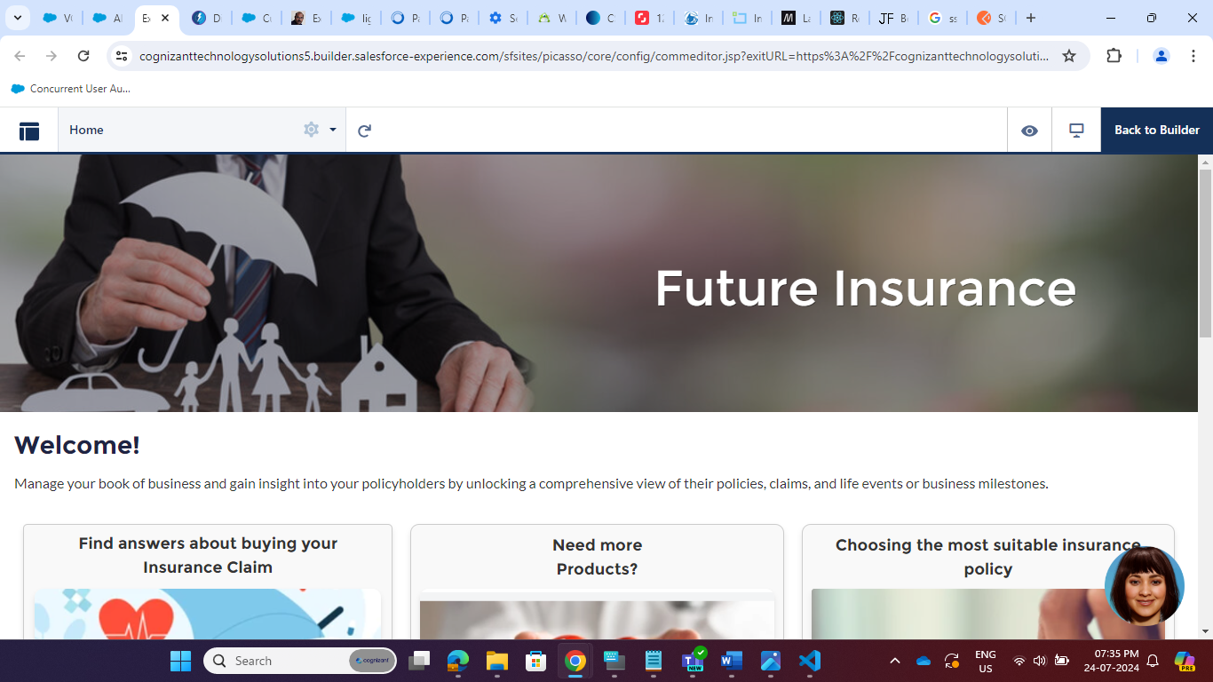

It is created by Simple HTML and CSS.

Body:

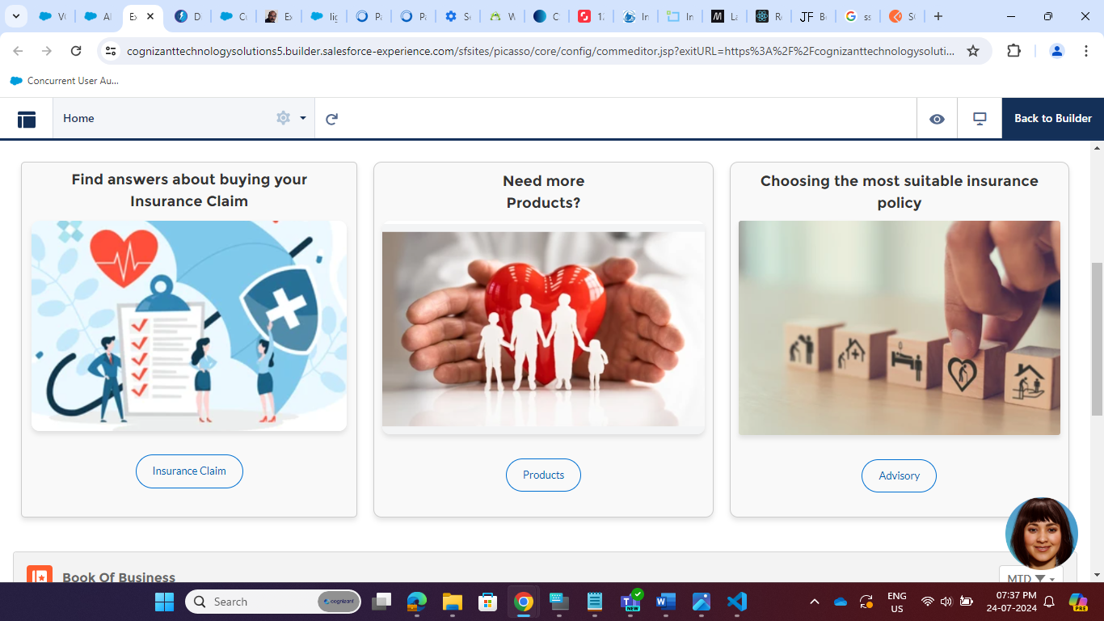

It Contant HTML and CSS:

HTML:

<div class="container">

<div class="columnimg2">

<h2>Find answers about buying your <br>Insurance Claim</h2>

<a href="/FAQ">

<img src="/sfsites/c/resource/FI_Insurance_claim" >

<br><br>

<a href="#" class="button">Insurance Claim</a>

<br>

</a>

</div>

<div class="columnimg1">

<h2>Need more <br>Products?</h2>

<a href="/FAQ">

<img src="/sfsites/c/resource/FI_Products">

<br><br>

<a href="#" class="button">Products</a>

<br><br>

</a>

</div>

<div class="column">

<h2>Choosing the most suitable insurance policy</h2>

<img src="/sfsites/c/resource/FI_Advisory">

<br><br>

<a href="#" class="button">Advisory</a>

<br><br>

</div>

</div>

Footer and Chat-Bot

It also Contant HTML and CSS

HTML:

<div class="footer-container">

<h3>Better benefits at Work.</h3>

<div class="footer-links">

<div class="footer-column">

<h4>Solutions for</h4>

<li>Employees & Families</li>

<li>Employers & plan Administrators</li>

<li>Brokers & Sales Partners</li>

<li>Dental Providers</li>

</div>

<div class="footer-column">

<h4>Join our team</h4>

<li>Careers</li>

<li>Corporate Offices</li>

<li>Life at future insurance</li>

</div>

<div class="footer-column">

<h4>How we can help</h4>

<li>Contact future insurance</li>

<li>File a Claim</li>

<li>SIP / STP</li>

<li>Inflation</li>

<li>Retirement</li>

</div>

<div class="footer-column">

<h4>FutureInsurance</h4>

<li>About Us</li>

<li>Investor Relations</li>

<li>Corporate Responsibility</li>

<li>Support</li>

<li>Help Center & FAQ</li>

</div>

</div>

<hr class="footer-separator">

<div class="footer-links">

<div class="footer-column">

<div class="footer-header">

<div class="logo"> <img src="/sfsites/c/resource/FI_Footer" alt="Logo"> </div>

<div class="social-icons"> <a href="#"><img src="/sfsites/c/resource/BB_Facebook_LOGO" alt="Facebook"></a> <a href="#"><img src="/sfsites/c/resource/BB_Twitter_LOGO" alt="Twitter"></a> <a href="#"><img src="/sfsites/c/resource/BB_Instagram_LOGO" alt="Instagram"></a> </div>

</div>

</div>

</div>

<div class="footer-copyright">

<p>Copyright © 2024 future insurance</p>

<div class="chat"> <a href="https://dji46dc70rn67.cloudfront.net/east1/digital-human/digital-human/custom-ui/insurance-v3/index.html"><img src="/sfsites/c/resource/DigitalAvatar" alt="ChatBot" width="90" height="90" ></a></div>

</div>

</div>

To control full Page Layout CSS:

/*---------------3 Columns----------------*/

.container {

display: flex;

flex-wrap: wrap;

justify-content: center;

}

.column {

flex: 1;

padding: 20px;

border: 1px solid #ccc;

border-radius: 10px;

box-shadow: 0 4px 6px rgba(0, 0, 0, 0.1);

text-align: center;

background-color: #f9f9f9;

margin: 10px;

transition: all 0.3s;

}

.column:hover {

transform: translateY(-5px);

box-shadow: 0 8px 12px rgba(0, 0, 0, 0.2);

}

.column img {

border-radius: 3px;

box-shadow: 0 4px 6px rgba(0, 0, 0, 0.1);

max-width: 100%;

height: auto;

margin-bottom: 10px;

}

.column h2 {

margin-bottom: 8px;

color: #333;

}

.column p {

margin-bottom: 10px;

color: #666;

}

.columnimg1 {

flex: 1;

padding: 20px;

border: 1px solid #ccc;

border-radius: 10px;

box-shadow: 0 4px 6px rgba(0, 0, 0, 0.1);

text-align: center;

background-color: #f9f9f9;

margin: 10px;

transition: all 0.3s;

}

.columnimg1 img {

border-radius: 10px;

box-shadow: 0 4px 6px rgba(0, 0, 0, 0.1);

max-width: 100%;

height: auto;

margin-bottom: 10px;

}

.columnimg1:hover {

transform: translateY(-5px);

box-shadow: 0 8px 12px rgba(0, 0, 0, 0.2);

}

.columnimg1 h2 {

margin-bottom: 8px;

color: #333;

}

.columnimg1 p {

margin-bottom: 10px;

color: #666;

}

.columnimg2, .columnimg1, .column {

flex: 1 1 100%;

padding: 10px;

}

@media only screen and (min-width: 768px) {

.columnimg2, .columnimg1, .column {

flex: 1;

}

}

.forceCommunityThemeHeroBase .contentTitle {

font-size: 3.5rem;

/* line-height: 1.1; */

margin-top: 12px;

text-indent: 600px;

}

/*------Column image 1 -----*/

.columnimg2 {

flex: 1;

padding: 8px;

border: 1px solid #ccc;

border-radius: 5px;

box-shadow: 0 4px 6px rgba(0, 0, 0, 0.1);

text-align: center;

background-color: #f9f9f9;

margin: 10px;

transition: all 0.3s;

}

.columnimg2 img {

border-radius: 10px;

box-shadow: 0 4px 6px rgba(0, 0, 0, 0.1);

max-width: 98%;

height: auto;

margin-bottom: 10px;

}

.columnimg2:hover {

transform: translateY(-5px);

box-shadow: 0 8px 12px rgba(0, 0, 0, 0.2);

}

.columnimg2 h2 {

margin-bottom: 10px;

color: #333;

}

.columnimg2 p {

margin-bottom: 10px;

color: #666;

}

.button {

display: inline-block;

padding: 10px 20px;

background-color: transparent;

color: #0070d2;

text-decoration: none;

border: 1px solid #0070d2; /* Thin border */

border-radius: 25px;

text-align: center;

transition: background-color 0.3s;

}

.button:hover {

background-color: rgba(0, 112, 210, 0.1);

}

/*---------------footer----------------*/

.footer-container {

background-color: #8a7f77; /* Dark greenish color for the entire division */

color: #fff; /* Text color */

}

.footer {

text-align: left;

}

.footer-links {

display: flex;

justify-content: space-around;

align-items: flex-start;

flex-wrap: wrap;

}

.footer-column {

flex: 1;

margin-right: 20px;

margin-bottom: 20px;

padding-left: 20px;

padding-top: 10px; /* Add padding from the starting point */

}

ul {

list-style-type: none;

padding: 0;

text-align: left; /* Align text to the left */

}

ul li {

margin-bottom: 5px;

text-align: left; /* Align text to the left*/

}

ul li a {

text-decoration: none;

color: #fff; /* Change text color to white */

display: block;

transition: color 0.3s;

padding-left: 70px; /* Add left padding for bullet points */

}

ul li a:hover {

color: #ccc; /* Change text color on hover */

}

.footer-header {

display: flex;

justify-content: space-between;

align-items: center;

}

.logo img {

width: 100px; /* Adjust the width as needed */

}

.social-icons a {

margin-right: 10px;

}

.footer-separator {

border-top: 1px solid #ccc;

margin: 20px 0;

}

.footer-copyright {

background-color: #8a7f77;

padding: 10px;

font-size: 12px;

color: #fff;

}

.chat{

text-align : right;

position: fixed;

bottom: 10px;

right: 10px;

padding: 5px;

}

.logo img,

.social-icons img {

width: 50px; /* Adjust the width of the images as needed */

height: auto; /* Maintain aspect ratio */

}

.styled-list {

list-style-type: none;

padding: 0;

}

.styled-list li {

margin-bottom: 10px;

padding: 10px;

background-color: #f9f9f9;

border-radius: 5px;

}

.styled-list li a {

text-decoration: none;

color: #333;

display: block;

padding: 5px;

transition: background-color 0.3s;

}

.styled-list li a:hover {

background-color: #e9e9e9;

}

.footer-column h3 {

text-align: left; /* Align the heading to the left */

}

.footer-column ul {

list-style-type: none; /* Remove default list styles */

padding: 0; /* Remove default padding */

}

.footer-column ul li {

margin-bottom: 5px;

text-align: left; /* Align text to the left */

}

.footer-column ul li:before {

content: none; /* Remove bullet point */

}

/*----------- FSD Details Heading ---------------*/

.heading {

text-align: center;

margin-top: 20px;

}

h1 {

font-size: 2.5em;

color: #333; /* Heading color */

margin-bottom: 10px;

}

h2 {

font-size: 1.2em;

color: #666; /* Subtitle color */

}

h2 span {

color: #ff6347; /* Highlight "*" in red */

font-weight: bold;

}

.heading::after {

content: "";

display: block;

width: 100px;

height: 2px;

background-color: #ff6347; /* Underline color */

margin: 10px auto;

}

/*------------ fsd details end -------------*/

/*-------------------Header---------------*/

.forceCommunityThemeHeroBase .contentCaption {

font-size: 50px;

line-height: 1.5;

}

Working on Chat-bot not completed Yet….(Completed)

HTML:

<template>

<!-- Widget Icon -->

<div class="widget-icon" onclick={togglePopup}>

<span><img src={DigitalHumanMary} alt="Nexa" style="width:90px;height:90px"></span>

</div>

<div>

<span class="ask-nexa"><b>Ask Mary</b></span>

</div>

<!-- Popup -->

<div class="popup" style="display:none">

<iframe src="https://dji46dc70rn67.cloudfront.net/east1/digital-human/digital-human/custom-ui/insurance-v3/index.html"

allow="camera https://dji46dc70rn67.cloudfront.net; microphone https://dji46dc70rn67.cloudfront.net"

frameborder="0" style="width: 100%; height: 100%;" allowfullscreen scrolling="no"></iframe>

</div>

</template>

JS:

import { LightningElement } from 'lwc';

import DHumanMary from '@salesforce/resourceUrl/DigitalAvatar';

export default class DigitalHumanMary extends LightningElement {

DigitalHumanMary =DHumanMary ;

// Add click event listener to the widget icon

// connectedCallback() {

// const widgetIcon = this.template.querySelector('.widget-icon');

// widgetIcon.addEventListener('click', () => {

// this.togglePopup();

// });

// }

// Function to open the popup

togglePopup() {

const popup = this.template.querySelector('.popup');

if (popup.style.display === 'none') {

popup.style.display = 'block';

} else {

popup.style.display = 'none';

}

}

}

CSS:

/* Style for the widget icon */

.widget-icon {

position: fixed;

width: 90px;

height: 90px;

right: 20px;

bottom: 100px;

color: #fff;

border-radius: 50%;

display: flex;

justify-content: center;

align-items: center;

cursor: pointer;

}

/* Style for the popup */

.popup {

display: none;

position: absolute;

bottom: 20px;

right: 20px;

width: 75%;

height: 500px;

border: 1px solid #ccc;

background-color: #fff;

z-index: 9999;

overflow: none;

}

/* Style for close button */

.close {

position: absolute;

top: 10px;

right: 10px;

cursor: pointer;

}

[data-title] {

position: relative;

}

.ask-nexa {

color: black;

bottom: 35px;

right: 35px;

bottom: 81px;

position: fixed;

}

Meta.xml

<?xml version="1.0"?>

<LightningComponentBundle xmlns="http://soap.sforce.com/2006/04/metadata">

<apiVersion>57.0</apiVersion>

<isExposed>true</isExposed>

<targets>

<target>lightning__RecordPage</target>

<target>lightning__AppPage</target>

<target>lightning__HomePage</target>

<target>lightning__FlowScreen</target>

<target>lightning__UtilityBar</target>

<target>lightningCommunity__Page</target>

<target>lightningCommunity__Default</target>

</targets>

</LightningComponentBundle>

Content Security Policy (CSP): we have to give permission to access chatbot.

Link: <https://cognizanttechnologysolutions5.my.site.com/futureInsurance>